**Task No 4**

**Python Programming**

**Name: Hamna Jahangir**

**Date: July 27,2024**

**Code:**

**from flask import Flask, request, jsonify**

**from flask_sqlalchemy import SQLAlchemy**

**app = Flask(__name__)**

**app.config['SQLALCHEMY_DATABASE_URI'] = 'sqlite:///items.db'**

**db = SQLAlchemy(app)**

**class Item(db.Model):**

**id = db.Column(db.Integer, primary_key=True)**

**name = db.Column(db.String(80), nullable=False)**

**description = db.Column(db.String(200), nullable=True)**

**db.create_all()**

**@app.route('/items', methods=['GET'])**

**def get_items():**

**items = Item.query.all()**

**return jsonify([{'id': item.id, 'name': item.name, 'description': item.description} for item in items])**

**@app.route('/items/<int:item_id>', methods=['GET'])**

**def get_item(item_id):**

**item = Item.query.get(item_id)**

**if item:**

**return jsonify({'id': item.id, 'name': item.name, 'description': item.description})**

**else:**

**return jsonify(message="Item not found"), 404**

**@app.route('/items', methods=['POST'])**

**def create_item():**

**data = request.get_json()**

**new_item = Item(name=data['name'], description=data.get('description', ''))**

**db.session.add(new_item)**

**db.session.commit()**

**return jsonify(message="Item created"), 201**

**@app.route('/items/<int:item_id>', methods=['PUT'])**

**def update_item(item_id):**

**data = request.get_json()**

**item = Item.query.get(item_id)**

**if item:**

**item.name = data['name']**

**item.description = data.get('description', item.description)**

**db.session.commit()**

**return jsonify(message="Item updated")**

**else:**

**return jsonify(message="Item not found"), 404**

**@app.route('/items/<int:item_id>', methods=['DELETE'])**

**def delete_item(item_id):**

**item = Item.query.get(item_id)**

**if item:**

**db.session.delete(item)**

**db.session.commit()**

**return jsonify(message="Item deleted")**

**else:**

**return jsonify(message="Item not found"), 404**

**if __name__ == '__main__':**

**app.run(debug=True)**

**Output:**







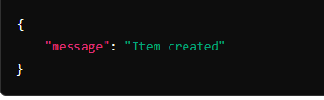



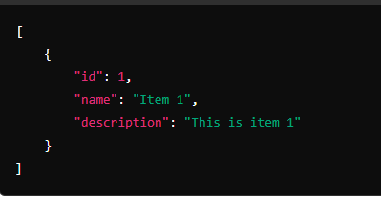



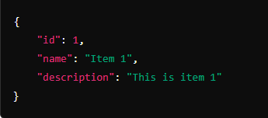



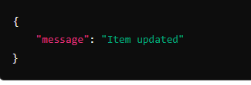



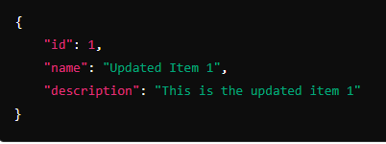

**Github link:**

**<https://github.com/Hamna-123739/DEP-Python-programming>**

**Linkedln link:**

**<https://www.linkedin.com/in/hamna-jahangir-51b3a9311?utm_source=share&utm_campaign=share_via&utm_content=profile&utm_medium=android_app>**